MEDIA KIT

A DECEMBER WITH A DUKE
Seductive Scoundrels Series, Book Three
Publisher: Blue Rose Romance

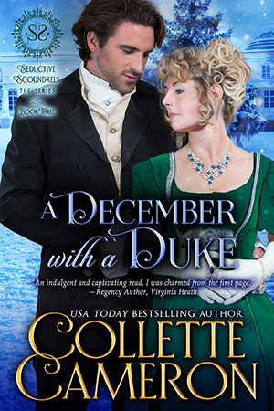

He’s entirely the wrong sort of man. That’s what makes him so utterly right.

After a horrific marriage, widow Everleigh Chatterton is cynical and leery of men. She rarely ventures into society, and when she must, she barely speaks to them. Her one regret for refusing to marry again is that she’ll never bear children. As a favor to a friend, she reluctantly agrees to attend a Christmas house-party. Unfortunately, Griffin, Duke of Sheffield is also in attendance. Even though Everleigh has previously snubbed him, she can’t deny her attraction to the confident, darkly handsome duke.

For almost a year, Griffin has searched for the perfect duchess to help care for the orphan he’s taken on. He sets his sights on the exquisite, but unapproachable widow after her sweet interactions with the child impress him. Everleigh vows she’s not interested in him or any other man. But Griffin is convinced he can thaw her icy exterior and free the warm, passionate woman lurking behind the arctic facade. Only, as he pursues her, it’s his heart that’s transformed.

Can Everleigh learn to trust and love again? Will Griffin get his Christmas wish and make her his bride? Or, has he underestimated her wounds and fears and be forced to let her go?

This book is part of a series but it can be read as a stand-alone.

Get this romantic heart-warming Regency Yuletide story you’ll want to read in one sitting.

REVIEWS:

Overall, sweet and uplifting. ★★★★★~Flippin’ Pages Blog

“Lovely, lighthearted …had me smiling, laughing, and just feeling soppy…Christmas romance you just have to love.” ★★★★★~Dragon Rose Books Blog

“…engaging, heartfelt holiday romance. I read the story in one sitting…This is the first book that I have read by this talented author, but it won’t be my last.” ★★★★★~Peg @ Writer to Escape

“I loved this story, it is inspiring and very emotional…”★★★★★~TracyJane

“This wonderful and yet tragic story is one that I could not stop reading…I highly recommend this wonderful holiday book.” ★★★★★~Kat Wiley

“The amazing Ms. Cameron has done it again. A wonderful story with real characters and real problems to be dealt with.” ★★★★★~Marc Davidson

“A heartwarming story of patience and love…The perfect Christmas story!” ★★★★★~David Wissore

“A heartwarming story and lovable characters…make this a winner.” ★★★★★~Peggy

EXCERPT:

A chorus of laughter spilled from the drawing room, the gaiety echoing down the gleaming marble-floored corridor. The jollity neither enticed Everleigh nor piqued her interest. A hand resting on the banister and her foot poised on the bottom riser, she slanted her head, listening.
That did not sound like the small, intimate gathering Theadosia, Duchess of Sutcliffe, had promised for the nearly month-long house party.
Only close friends and family had been invited, Thea had assured her when she cajoled Everleigh into staying at Ridgewood Court rather than going home to Fittledale Park each evening. Probably because she knew full well Everleigh wasn’t likely to return every day, if at all.
Thea had vowed there wouldn’t be a soul who would make Everleigh feel the least uncomfortable, nor any rapscallions inclined to pursue widowed heiresses almost four-and-twenty years of age.
Only eleven people had gathered for tea this afternoon. Afterward, the men—the Duke of Sutcliffe, three other peers of the realm (all dukes as well) and James Brentwood, Thea’s brother—had gone riding.
Not Everleigh’s definition of a cozy assembly. Two or three at most fit that description.
Nonetheless, the number was sufferable, for a few days at least. Especially since the other females included her cousins Ophelia and Gabriella Breckensole, as well as her step-niece Rayne Westbrook and Theadosia’s sister, Jessica. The other women planning to attend the house party would join them for dinner.
Who else had arrived while Everleigh napped the afternoon and early evening away in an attempt to ease the megrim still niggling around her temples?
Too much excitement—make that tension caused by her dread of gatherings—inevitably brought a headache on. A dose of powders and a lie-down in a darkened chamber with a cool, damp cloth across her eyes had reduced this one to a dull annoyance. Still, the minor throbbing provided a perfect excuse to retire early should the need arise.
Another burst of laughter erupted, this one mostly masculine chortles.
That boisterous din couldn’t be merely the five men from tea. Precisely how many upper crust chaps had been invited? The same number as females to balance the dinner table?
If so, that likely meant four more strutting peacocks. No doubt pampered and privileged gentlemen with nothing better or more meaningful to do with their time than fritter it away at a house party. Or, as experience had taught her, indulge in a dalliance or two or three for the party’s endurance.
How many times had she witnessed that very thing during the two miserable years she’d been wife to Arnold Chatterton? How many times had her depraved husband carried on with one shameless gillflurt or another whilst Everleigh barricaded herself in her bedchamber to escape the vile intentions of the other debauchees in attendance?
A shiver juddered across her shoulders, and she firmed her mouth and gave a little shake of her head.
Chatterton was dead.
He had been for almost two years.
He couldn’t hurt her anymore.
Neither could his son.
In any event, Theadosia, the daughter of a reverend, wouldn’t tolerate those sorts of shenanigans beneath her roof. But how was Thea to know who prowled about in the middle of the night, or what fiend might waylay and force themselves on an unsuspecting lady?
Would all the guests remain until Christmastide?
Boxing Day?
Twelfth Night?
If so, Everleigh assuredly would not.
She enjoyed her solitude too much, hence her turreted bedchamber at Ridgewood, specifically selected for its privacy and isolation from the rest of the guests. Only two other bedchambers and the nursery lay in that wing—all blessedly unoccupied. At least they had been when she’d made her way to her room this afternoon.
She’d heard nothing on her way down to dinner to suggest otherwise.
Descending the last stair, she wrapped her lace shawl closer around her shoulders and weighed her options. She could return to her chamber and request a carriage to take her home. She didn’t much care that doing so would certainly advance her reputation for icy aloofness. But it would also hurt Theadosia’s feelings, and that Everleigh did care about.
A great deal, truth to tell.
Theadosia was one of the few people who hadn’t judged her, who had remained a true friend.
On the other hand, Everleigh could muster her courage and see who’d arrived and then decide whether to escape. Waylaying a footman and asking him to reel off the names of the guests probably wasn’t a good idea, though of the choices, it held the most appeal.
Confound Thea, the compassionate, meddling wretch, for her tender heart and her ongoing efforts to entice Everleigh into Society again. Drat Thea’s determination to help Everleigh overcome her fears and heal. And above all, a pox on her hints that Everleigh should consider allowing suitors to call upon her.
Even—God forbid!—contemplate marriage once more.
Didn’t she want children? Thea had asked kindly.
With all my heart.
But marry? Be leg-shackled again? Under a man’s thumb, and her every movement dictated?
No. No!
Never. Ever. Again.
She refused to subject herself to le beau monde’s marriage mart or consider matrimony. Her experiences in those areas had proved intolerable, and she’d no wish to repeat them.
Some things one never recovered from, but unless a person had lived through that awfulness, they simply couldn’t understand, so Theadosia couldn’t be faulted for her efforts. Everleigh’s wounds mightn’t have been physical, but the scars on her soul had all but crippled her ability to feel.
Theadosia and Sutcliffe’s union was a love match. How could Thea possibly appreciate Everleigh’s aversion to marriage?
To men?
Or her immense dislike of December?
How she loathed the month.

BUY LINKS:

Amazon | Barnes & Noble | Kobo | Google Play | iBooks

Amazon: https://www.amazon.com/gp/product/B07L5266HS?tag=collett-20
Barnes & Noble: https://www.barnesandnoble.com/w/a-december-with-a-duke-collette-cameron/1129978572?ean=2940156306220
Kobo: https://www.kobo.com/us/en/ebook/a-december-with-a-duke
Google Play: https://play.google.com/store/books/details/Collette_Cameron_A_December_with_a_Duke?id=PW99DwAAQBAJ
iBooks: https://geo.itunes.apple.com/us/book/a-december-with-a-duke/id1445632092?mt=11at=1010lIAW

About the Author: Collette Cameron

USA Today Bestselling, award-winning author, COLLETTE CAMERON pens Scottish and Regency historicals, featuring rogues, rapscallions, rakes, and the intelligent, intrepid damsels who reform them.

Blessed with fantastic fans as well as a compulsive, over-active, and witty Muse who won’t stop whispering new romantic romps in her ear, she lives in Oregon with her mini-dachshunds, though she dreams of living in Scotland part-time.

You’ll always find dogs, birds, occasionally naughty humor, and a dash of inspiration in her sweet-to-spicy timeless romances®.

Her motto for life? You can’t have too much chocolate, too many hugs, too many flowers, or too many books. She’s thinking about adding shoes to that list.

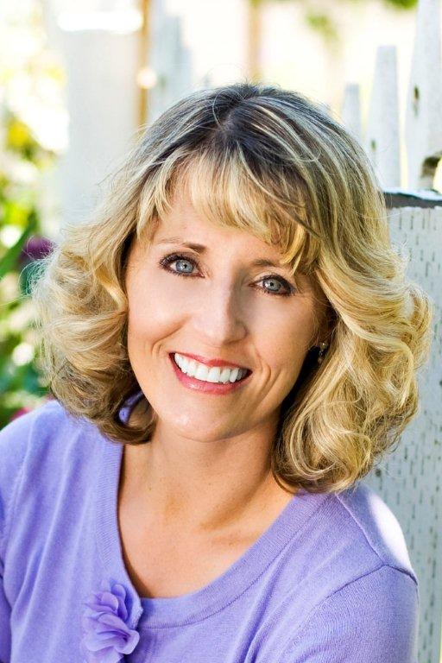

Connect with Collette:

Website | Blue Rose Romance Blog | Twitter | Facebook | Newsletter

Website: https://collettecameron.com/
Blue Rose Romance Blog: https://collettecameron.com/blue-rose-romance-blog/
Facebook: http://facebook.com/collettecameronauthor
Twitter: http://twitter.com/Collette_Author
BookBub: https://www.bookbub.com/authors/collette-cameron
Pinterest: https://www.pinterest.com/colletteauthor/
Amazon Author Page: https://www.amazon.com/Collette-Cameron/e/B00CWLYXL2
Goodreads: https://www.goodreads.com/author/show/7047979.Collette_Cameron
Newsletter: http://bit.ly/TheRegencyRose_ColletteCameron
GooglePlay: https://plus.google.com/u/0/+ColletteCameronAuthor/
LinkedIn: https://www.linkedin.com/in/collette-cameron-usa-today-bestselling-author-66717a60/

