MEDIA KIT

ONLY A DUKE WOULD DARE
Seductive Scoundrels Series, Book Two
Publisher: Blue Rose Romance

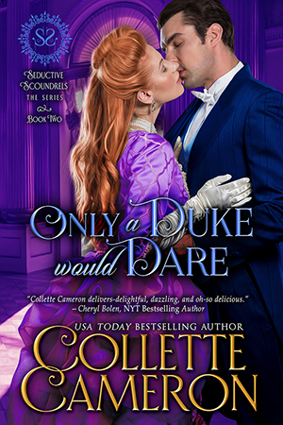

Faced with an impossible choice, could you devastate someone you love?

Caution: This book contains a philandering hero with a heart of gold, a fearless heroine adamant she’ll decide her own destiny, a passel of roguish dukes and the daring damsels determined not to be seduced by them, and unforeseen twists that will keep you turning page after page.

Marriage—an unpleasant obligation
A troublesome addendum to his father’s will requires Victor, Duke of Sutcliffe to marry before his twenty-seventh birthday. That doesn’t mean he intends to alter his pleasure-seeking lifestyle. Mere weeks before he must wed, he ventures home, intent on finding the most biddable, forgettable miss in all of Essex. Except the first woman he encounters stirs far more than his interest, and Theadosia Brentwood is anything but unremarkable or dowdy.
Marriage—an impossible choice
Against her better judgement, and despite her father promising her hand to a man she detests, Theadosia clandestinely meets with Victor. Though she’s far beneath his station and aware he must marry soon, she can’t deny her growing fascination. When Victor unexpectedly proposes, Thea must make an unbearable decision—refuse to marry her father’s pick and elope with Victor, who wouldn’t wed at all except to save his fortune. If she does, her betrothed will reveal a scandalous secret, sending her father to prison and rendering her sister and mother homeless.

Buy this page-turning book for an emotional, entertaining, and romantic Regency England adventure you won’t want to put down.

Though this book is part of a series, it can easily be read as a stand-alone novel.

REVIEWS:

“Delightful, dazzling, and oh-so delicious.” ★★★★★ ~Cheryl Bolen, NYT Bestselling Author

EXCERPT:

BUY LINKS:

Amazon | Barnes & Noble | Kobo | Google Play | iBooks

Amazon: https://www.amazon.com/dp/B07GCTQW2K/?tag=collett-20
Barnes & Noble: https://www.barnesandnoble.com/w/only-a-duke-would-dare-blue-rose-romance-collette-cameron-author/1129286495?ean=2940155711278
Kobo: https://www.kobo.com/us/en/ebook/only-a-duke-would-dare
Google Play: https://play.google.com/store/books/details/Collette_Cameron_Only_a_Duke_Would_Dare?id=tKVoDwAAQBAJ
iBooks: https://geo.itunes.apple.com/us/book/only-a-duke-would-dare/id1425545711?

About the Author: Collette Cameron

USA Today Bestselling, award-winning author, COLLETTE CAMERON pens Scottish and Regency historicals, featuring rogues, rapscallions, rakes, and the intelligent, intrepid damsels who reform them.

Blessed with fantastic fans as well as a compulsive, over-active, and witty Muse who won’t stop whispering new romantic romps in her ear, she lives in Oregon with her mini-dachshunds, though she dreams of living in Scotland part-time.

You’ll always find dogs, birds, occasionally naughty humor, and a dash of inspiration in her sweet-to-spicy timeless romances®.

Her motto for life? You can’t have too much chocolate, too many hugs, too many flowers, or too many books. She’s thinking about adding shoes to that list.



Connect with Collette:

Website | Blue Rose Romance Blog | Twitter | Facebook | Newsletter

Website: https://collettecameron.com/
Blue Rose Romance Blog: https://collettecameron.com/blue-rose-romance-blog/
Facebook: http://facebook.com/collettecameronauthor
Twitter: http://twitter.com/Collette_Author
BookBub: https://www.bookbub.com/authors/collette-cameron
Pinterest: https://www.pinterest.com/colletteauthor/
Amazon Author Page: https://www.amazon.com/Collette-Cameron/e/B00CWLYXL2
Goodreads: https://www.goodreads.com/author/show/7047979.Collette_Cameron
Newsletter: http://bit.ly/TheRegencyRose_ColletteCameron
GooglePlay: https://plus.google.com/u/0/+ColletteCameronAuthor/
LinkedIn: https://www.linkedin.com/in/collette-cameron-usa-today-bestselling-author-66717a60/

