Media Kit
Seductive Surrender
Highland Heather Romancing a Scot Series #6


Collette Cameron Author of Sweet-to-Spicy Timeless Romance

100 Word Bio:
A USA Today bestselling, award-winning author, COLLETTE CAMERON pens Scottish and Regency historicals featuring rogues, rapscallions, rakes, and the intelligent, intrepid damsels who reform them.

Blessed with fantastic fans, and a compulsive, over-active, and witty Muse who won’t stop whispering new romantic romps in her ear, she still lives in Oregon with her mini-dachshunds, though she dreams of living in Scotland part-time.

Admitting to a quirky sense of humor, Collette enjoys inspiring quotes, adores castles and anything cobalt blue, and is a self-confessed Cadbury chocoholic. You'll always find dogs, birds, occasionally naughty humor, and a dash of inspiration in her sweet-to-spicy timeless romances.

75 Word Bio:
USA Today bestselling, award-winning author, COLLETTE CAMERON pens Scottish and Regency historicals featuring rogues, rapscallions, rakes, and the intelligent, intrepid damsels who reform them.

Collette admits to a quirky sense of humor, enjoys inspiring quotes, and anything cobalt blue. A self-confessed Cadbury chocoholic, she lives in Oregon with her miniature dachshunds.

You'll always find dogs, birds, occasionally naughty humor, and a dash of inspiration in her sweet-to-spicy timeless romances.

SEDUCTIVE SURRENDER
Highland Heather Romancing a Scot Series #6

Dalliances, flirtations, liaisons? Aye. But marriage? Nae. Spies dinna wed

Betrothed four times.
Gwendolyn McClintock has resolutely slammed the door on romance and marriage. Intent on beginning a new life, she sells her beloved familial home in America and totes her orphaned niece and nephew to Scotland’s Highlands. But the grand adventure she promised becomes a tangled muddle when her coach accidentally runs down a powerful laird’s much-too-attractive, far-too-brawny brother.

A covert agent.
A confirmed, carefree rogue, Dugall Ferguson comes perilously close to being trampled beneath horses’ hooves. And the remorseful, deliciously tempting woman responsible for nearly killing him isn’t even aware of the peril awaiting her at her new home. Gwendolyn desperately needs protection, and though he’s on the cusp of realizing his life-long dream, Dugall rashly offers to aid the fiery lass.

Their futures collide.
Forced together in order to oust a would-be killer, irresistible passion erupts between Gwendolyn and Dugall. Dare she trust her traitorous heart one last time, especially to a known rake? How can he choose between his love for Gwendolyn and his desire to be a spy?

Read the sixth installment of the Highland Heather Romancing a Scot Series for a suspenseful Scottish historical romance awash with intrigue, seduction, and passion you won’t want to put down.

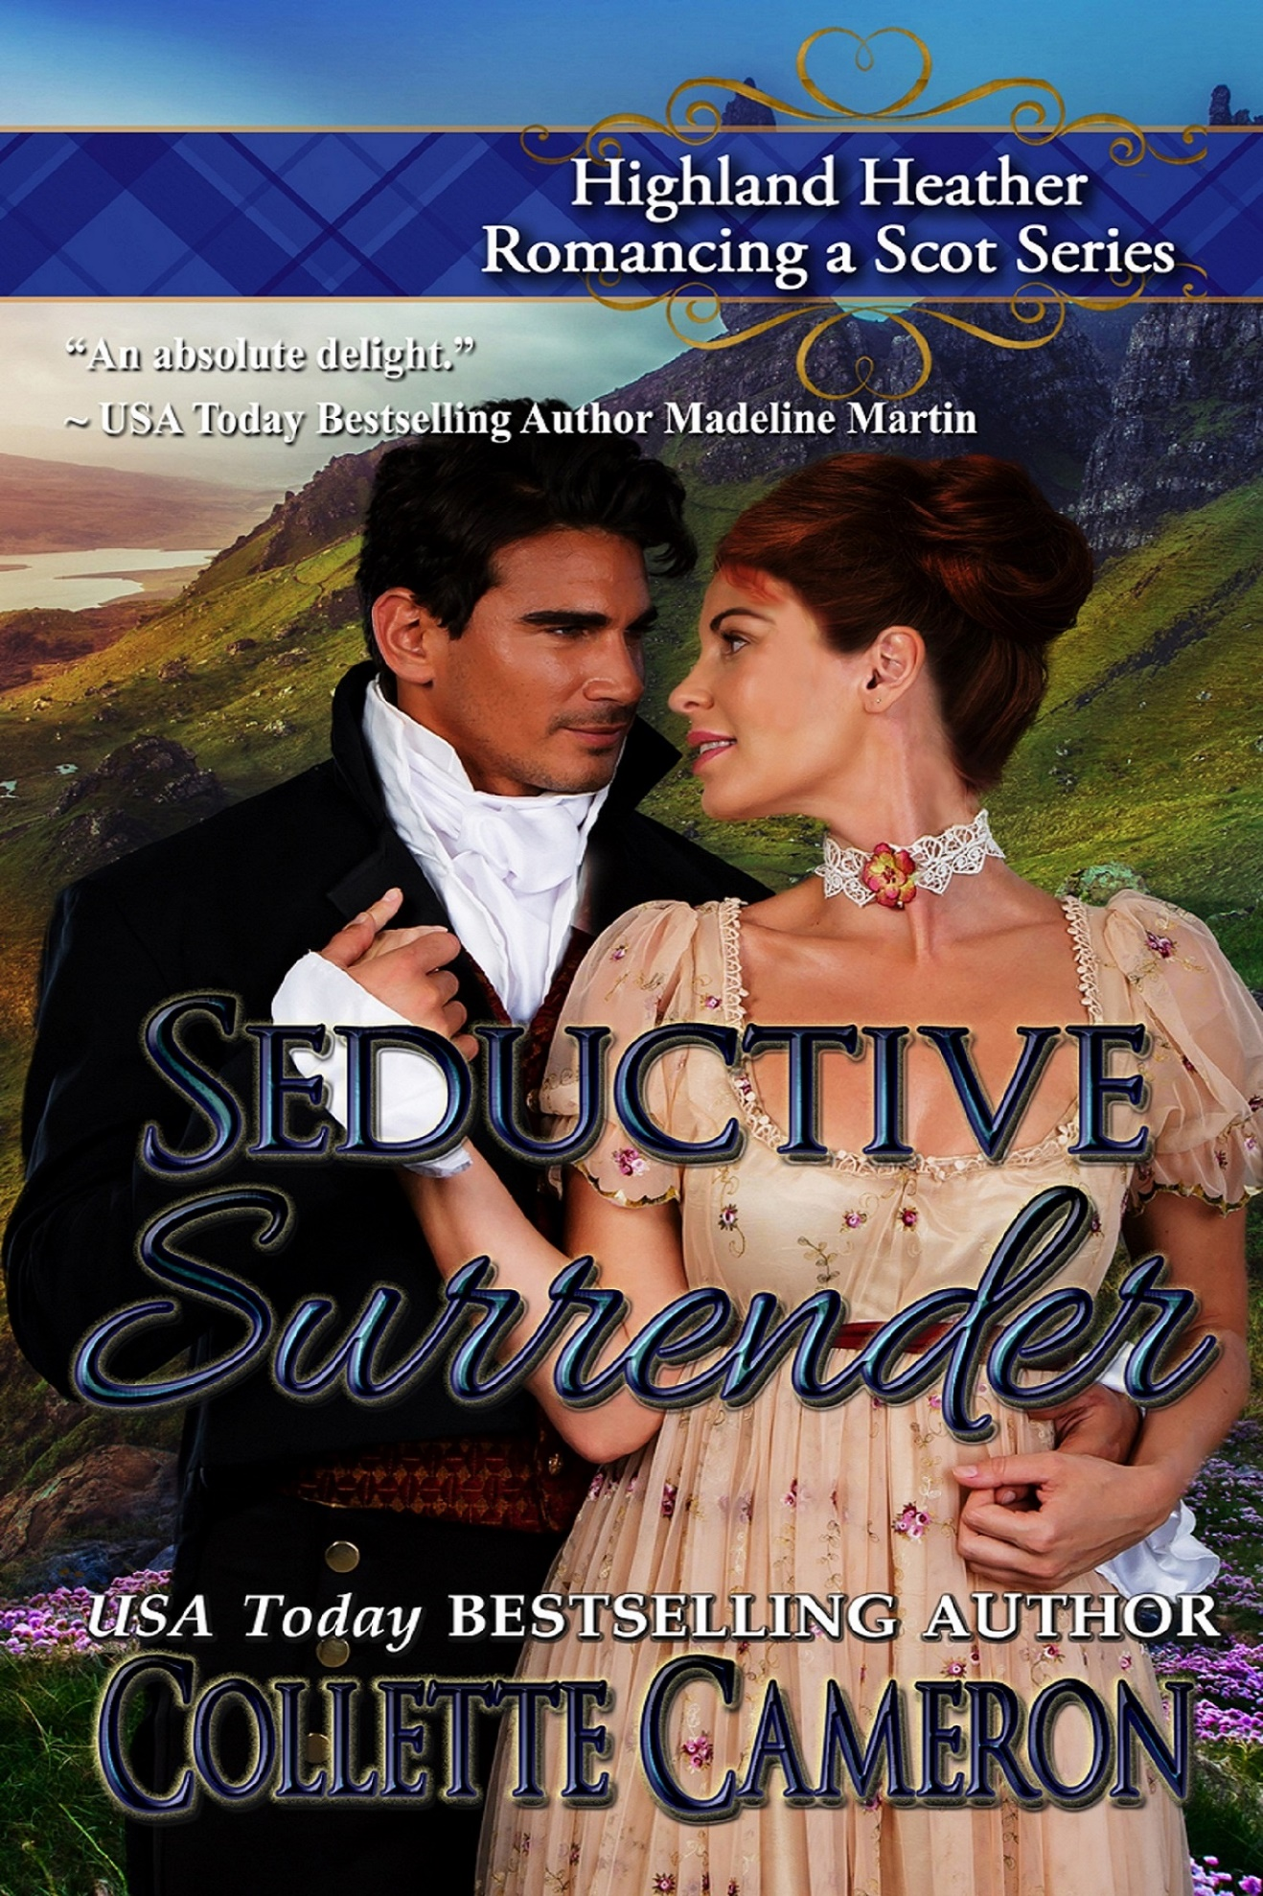
Publisher: Soul Mate Publishing
EXCERPT
Seductive Surrender

“She should have more care,” Gwendolyn muttered as she trailed her forefinger down his bicep. The flesh bunched in delicious anticipation as she traced his arm. “She told me she needs her position. I still might kick a mud hole in her hind end and stomp it dry.”
“Pardon?” he managed around the grin splitting his face.
“Send her packing for her untoward behavior.”
Daring to draw Gwendolyn indecently nearer, Dugall flattened one palm against the small of her back and cradled her jaw in the other. Feathering a series of short kisses from her delicate ear, across her soft cheek, and to her sweet mouth, he breathed, “Are ye jealous, Gwenny?”
She stiffened, all outraged femininity, then sagged against him, and nodded, her hair brushing his chest.
“Yes.”
“Ye needn’t be, leannan. The only lass I have any interest in kissin’ is in my arms.”

.
BUY LINK

Amazon: https://books2read.com/SSURcc

Connect with Collette

Get a FREE Starter Library! Join my VIP Reader Club: http://bit.ly/TheRegencyRose
Website: http://collettecameron.com
Blog: https://collettecameron.com/blue-rose-romance-blog/
Facebook: http://facebook.com/collettecameronauthor
Pinterest: http://www.pinterest.com/colletteauthor/
Twitter: http://twitter.com/Collette_Author
Amazon Author Page: http://amazon.com/author/collettecameron.com/
Book Bub: https://www.bookbub.com/authors/collette-cameron
Collette’s Chèris VIP Reader Group: https://www.facebook.com/groups/CollettesCheris/
Instagram: https://instagram.com/collettecameronauthor/
Newsletter: http://bit.ly/TheRegencyRose
Goodreads: https://www.goodreads.com/collettecameron
Google+: https://www.google.com/+ColletteCameronAuthor
LinkedIn: https://www.linkedin.com/in/collette-cameron-bestselling-award-winning-author-66717a60
Cafe Press: http://www.cafepress.com/collettecameronsblueroseromance
You Tube: http://www.youtube.com/c/ColletteCameronAuthor

Available in Audio Too

Reviews
"The chemistry and language between the two had me smiling and rooting for the romance to happen." ~Clarissa
"Enjoyed the romance, and the story kept me totally involved." ~Patricia
"An intriguing story with no shortage of villainous suspects. Fun characters that are easy to fall in live with."" ~Petula, Warrior Woman Winmill
"Southern and Scottish accents meet for a witty tale from the delightful Collette Cameron." ~Dee

"One of Collette's Best!!!" ~ Anissa
"...well-written plot that kept my interest until the end! Fast-paced, with engaging characters, a few funny scenes along the way and a great storyline! Again, I could not put it down! ~Nicole

