MEDIA KIT FOR A KISS FOR MISS KINGSLEY

A Kiss for Miss Kingsley
A Waltz with a Rogue Novella

COLLETTE CAMERON is a best-selling and award-winning Historical Romance Author of Scottish and Regency Romances featuring rogues, rapscallions, rakes, and the intrepid damsels who reform them. Mother to three and self-proclaimed Cadbury chocoholic, she’s crazy about dachshunds, cobalt blue, and makes her home in Oregon with her five mini-dachshunds. You'll always find animals, quirky—sometimes naughty—humor, and a dash of inspiration in her novels.
Her award-winning Castle Brides Series, Highland Heather Romancing a Scot Series, Conundrums of the Misses Culpepper Series, and A Waltz with a Rogue Novellas, as well as her other books, are all available on Amazon.



A Kiss for Miss Kingsley
A Waltz with a Rogue Novella
Olivia Kingsley didn’t expect to fall in love and receive a secret marriage proposal two weeks into her first Season. However, one dance with Allen Wimpleton, heir to a viscountcy, and her fate is sealed. Or so she thinks until her eccentric and ailing father, unaware of Allen’s proposal, announces he’s moving the family to the Caribbean for a year. ... In two days.

Allen begs Olivia to elope to Scotland, knowing her father will refuse his offer of marriage after such a brief acquaintance with Olivia. Having recently lost her mother, and fearing for her father’s health, she refuses, pleading with Allen to wait for her until she returns to England. Angry at her hesitancy, and unaware of her father’s ill health, Allen demands she choose—him or her father.

Heartbroken at his callousness, but thankful he’s revealed his true nature before she married him, Olivia turns her back on their love. The year becomes three, enough time for her broken heart to heal, and after her father dies, Olivia returns to England. Coming face to face with Allen, she realizes she never purged him from her heart and once again the flames of love ignite, but is it too late? Does Olivia have any hope of winning Allen’s heart once more, or has he found
another?

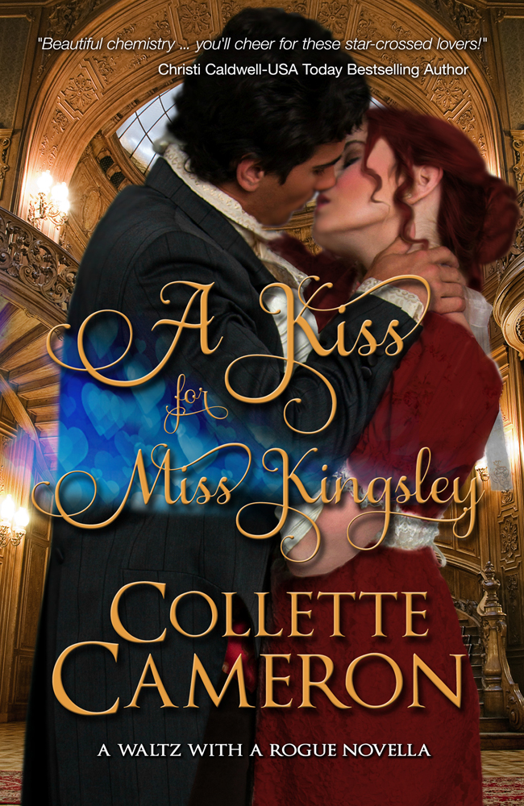
EXCERPT- Dance Scene
“This is a monumental mistake.” Fingering the ruby pendant hanging at her neck, Olivia Kingsley peeked out the window as the conveyance rounded the corner onto Berkeley Square. Carriage upon carriage, like great shiny beetles, lined up beside an ostentatious manor.
Guests in their evening finery swarmed before the grand entrance and on the stairs as they waited their turn to enter Viscount and Viscountess Wimpleton’s home.
Trepidation dried her mouth and tightened her chest. Yes, attending the ball was a featherbrained solicitation for disaster. No good could come of it.
God’s toenails, what was I thinking, agreeing to Auntie Muriel’s addlepated scheme?
Olivia flattened against the sky-blue squab in the corner of her aunt’s coach and vehemently shook her head. “I cannot do it.”
A curl came loose, plopping onto Olivia’s forehead.
Bother.
She shoved the annoying tendril beneath a pin, having no doubt the tresses would work their way free before evening’s end. Patting the circlet of rubies adorning her hair, she assured herself the band remained secure.
Her pulse beat an erratic staccato, and she searched for a plausible excuse for refusing to attend the ball after all.
“I ... We,” she wiggled her gloved fingers at her brother, Bradford, lounging on the opposite seat, appearing as contented as their fat cat, Socrates, after lapping a saucer of cream, “were not invited.”
Terribly gauche, that. Showing up at a haut ton function, no invitation in hand.
“Nonsense, darling. It’s perfectly acceptable for you to accompany me.” Aunt Muriel, the Duchess of Daventry, patted Olivia’s knee with her plump hand. “Lady Wimpleton is one of my dearest friends. Why, we had our come-out together, and I’m positive had she known that you and Bradford had recently returned to England, she would have extended an invitation herself.”
Not if she knew the volatile way her son and I parted company, she wouldn’t have.

BUY LINKS
Amazon: httm://amzn./B00QSNVG1K/
Barnes & Noble: http://www.barnesandnoble.com/w/a-kiss-for-miss-kingsley-collette-cameron/1120949346?ean=2940149996025
iBOOKS: https://itunes.apple.com/us/book/a-kiss-for-miss-kingsley/id950137983?ls=1&mt=11
Kobo: http://store.kobobooks.com/en-US/ebook/a-kiss-for-miss-kingsley

AMAZON BARNES & NOBLE iBOOKS KOBO

Connect with Collette:

Website Blue Rose Romance Blog Twitter Facebook Newsletter

Website: http://collettecameron.com
Facebook: http://facebook.com/collettecameronauthor
Blue Rose Romance Blog: http://collettecameron.com
Twitter: http://twitter.com/collette_author
Pinterest: http://www.pinterest.com/colletteauthor/
Amazon Author Page http://www.amazon.com/Collette-Cameron/e/B00CWLYXL2
Goodreads: https://www.goodreads.com/author/show/7047979.Collette_Cameron

Newsletter: http://tinyurl.com/regencyrose
Google+: https://plus.google.com/u/0/+ColletteCameronAuthor/
LinkedIn: https://www.linkedin.com/profile/view?id=215403055&trk=hp-identity-name

